CENG465 – Machine Learning Project Report

GUI-Based Machine Learning Toolkit for Classification & Evaluation
Course: CENG465 – Machine Learning
Group Members
Name | Student ID
Melek Arslan | 220446018
Alp Doruk Şengün | 230444401
Mehmet Anıl Ülkü | 220441001
Yusuf Özoğul | 230446401
Saip Deniz İnal | 210444087
Abstract
This project introduces a GUI-based Machine Learning Toolkit developed with Python and Streamlit. The application allows users to upload CSV datasets, apply preprocessing techniques, train classification models, and evaluate their performance using standard metrics. The toolkit supports Perceptron, Multilayer Perceptron (MLP), and Decision Tree classifiers. A notable contribution is the custom implementation of an MLP trained via the backpropagation algorithm, enabling configurable network architectures and transparent learning behavior.
Keywords: Machine Learning, Classification, Backpropagation, GUI
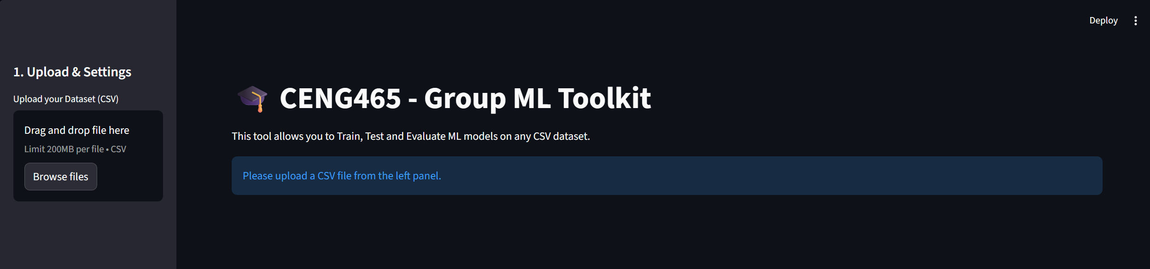

1. Introduction & Problem Definition
Machine learning classification methods are widely used to automatically assign data samples to predefined classes. However, experimenting with different models, preprocessing techniques, and evaluation metrics often requires substantial coding experience.
The aim of this project is to provide a user-friendly graphical interface that simplifies classification experiments. Users can upload datasets, configure preprocessing steps, train multiple models, and compare their results within a single environment. To demonstrate a solid understanding of neural networks, a Multilayer Perceptron trained with a custom backpropagation algorithm is implemented instead of relying solely on black-box libraries.
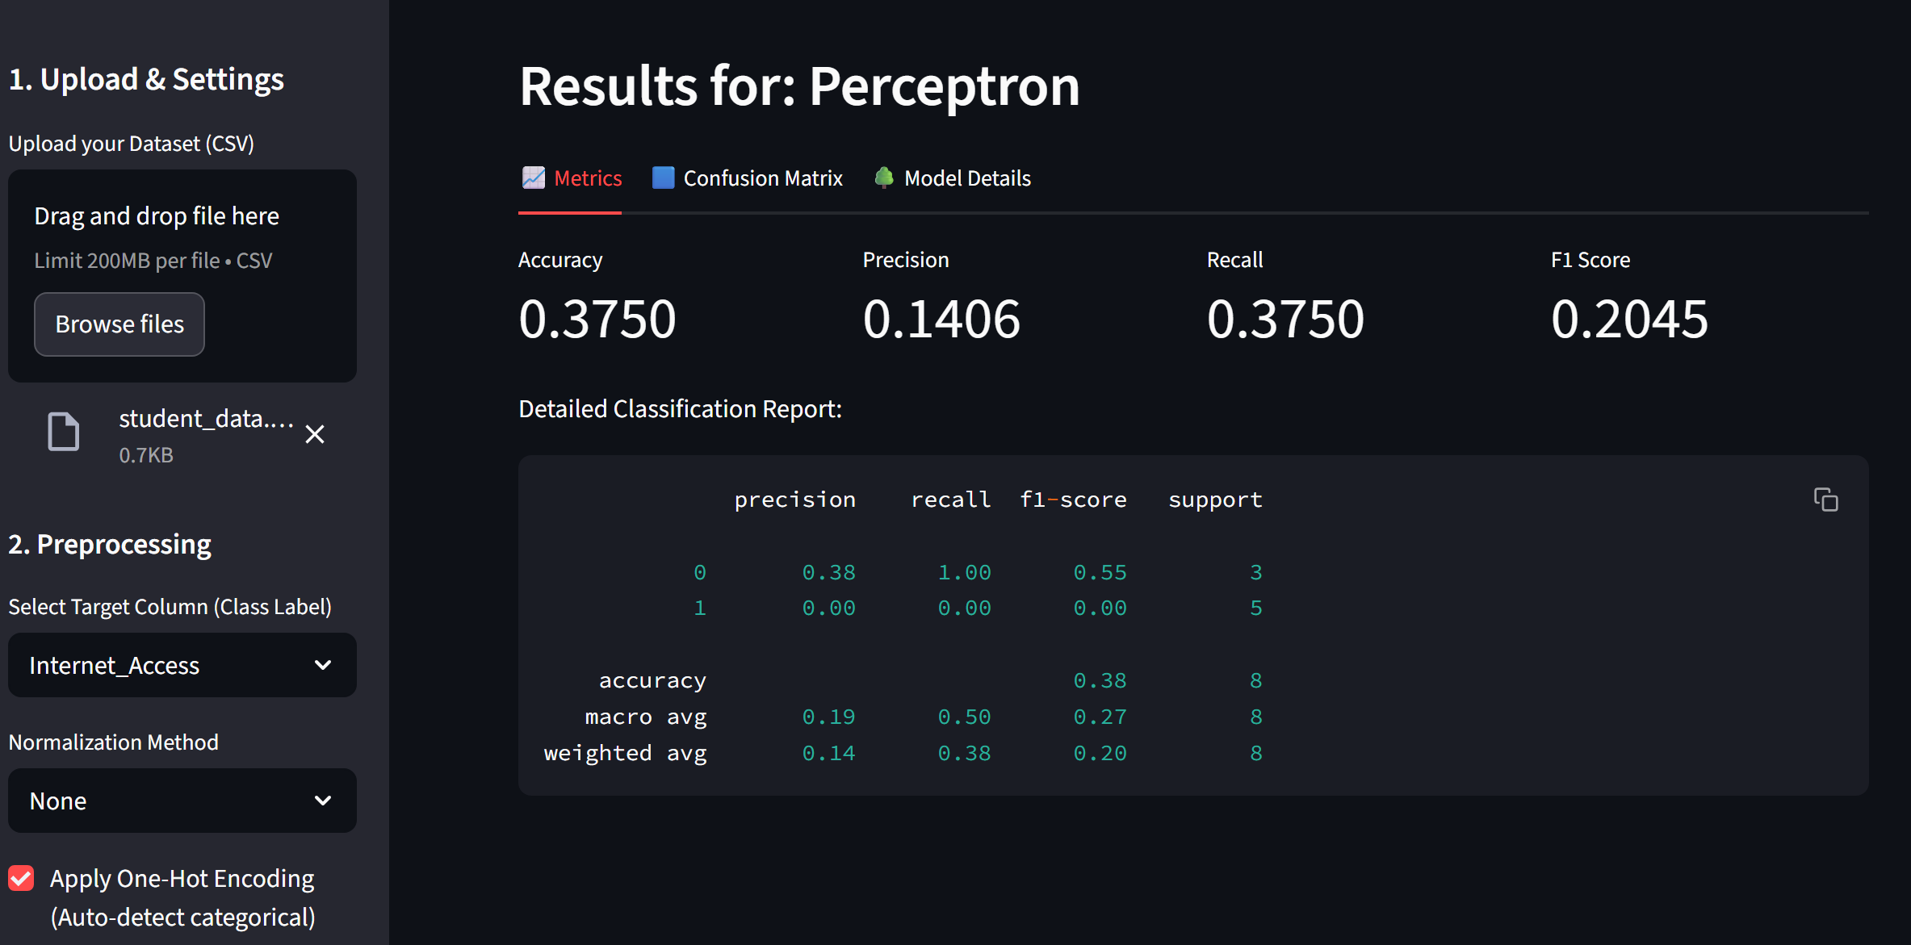

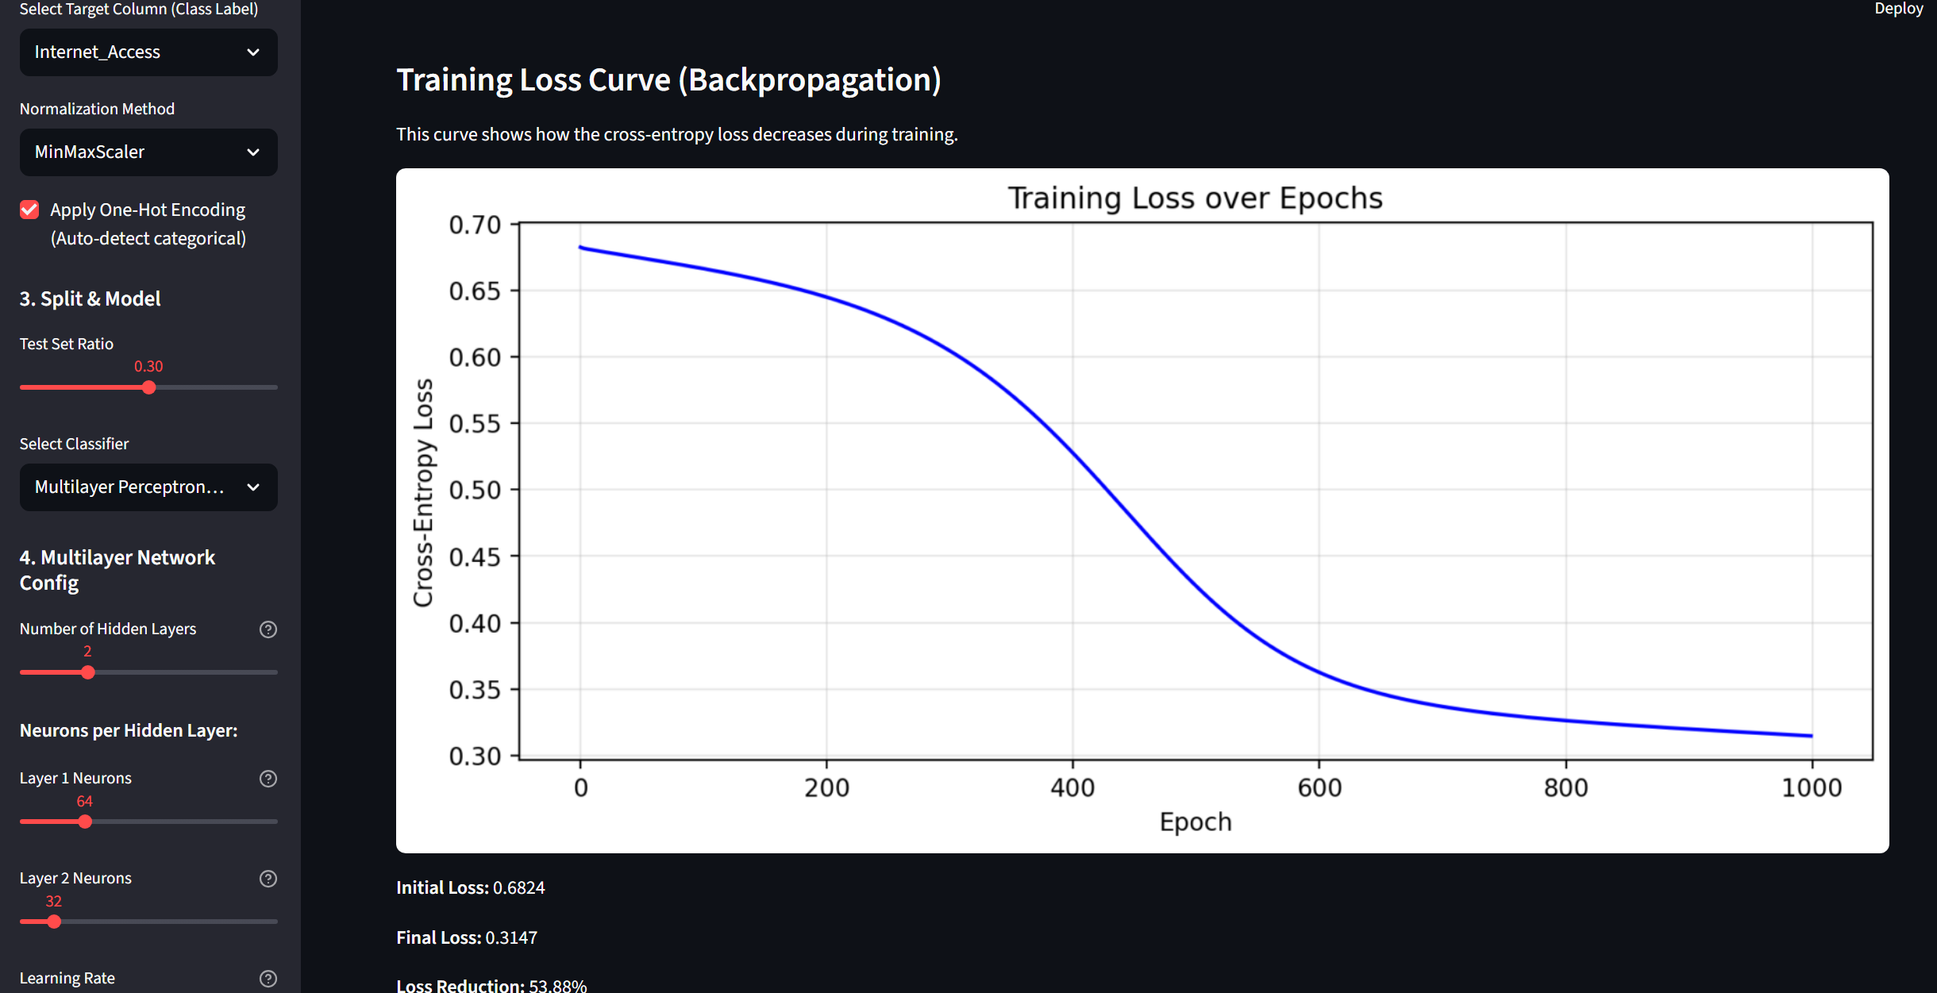

2. Dataset Description
The toolkit accepts user-provided datasets in CSV format and supports both binary and multi-class classification. During testing, publicly available datasets containing numerical and categorical features were used.
Typical dataset characteristics include 1,000 samples, 8–15 features, 2–3 classes, and a 70/30 train-test split. Feature types are automatically detected and processed based on user selections.
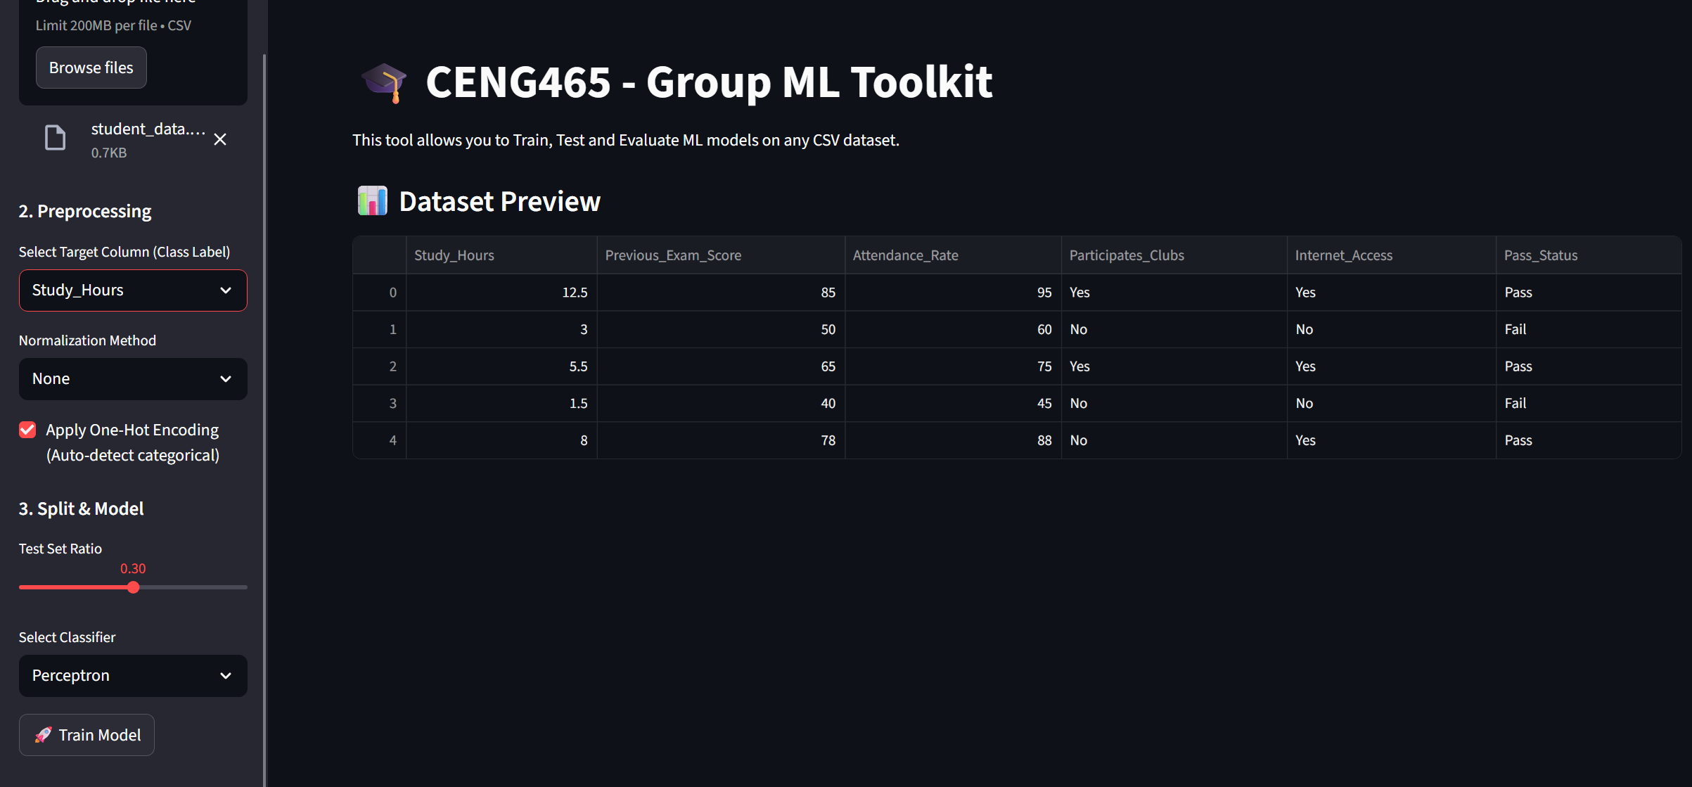
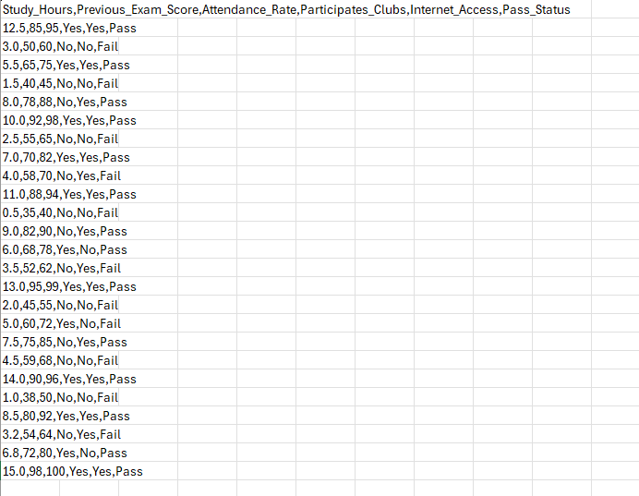

3. GUI Design and Features
The graphical user interface is implemented using Streamlit and provides an intuitive, web-based workflow. The interface guides users through dataset upload, preprocessing selection, model configuration, training, and result visualization.
Key features include CSV upload, target selection, preprocessing options, model selection, adjustable train-test split, and visualization of evaluation metrics and confusion matrices.

4. Preprocessing Choices
Preprocessing is essential for reliable classification performance. The toolkit supports feature normalization and categorical data encoding.
StandardScaler and Min-Max scaling are available for normalization, which is particularly important for Perceptron and MLP models. Categorical features are transformed using one-hot encoding to ensure compatibility with neural network-based classifiers.

5. Model Descriptions
Perceptron: A simple linear classifier used as a baseline model. It is fast but limited to linearly separable data.
Multilayer Perceptron (Custom): A fully connected neural network implemented from scratch using NumPy. It supports configurable hidden layers, Sigmoid/ReLU activations, cross-entropy loss, and training via backpropagation and gradient descent.
Decision Tree: A tree-based classifier using entropy and information gain. It is interpretable and does not require feature scaling but may overfit without constraints.
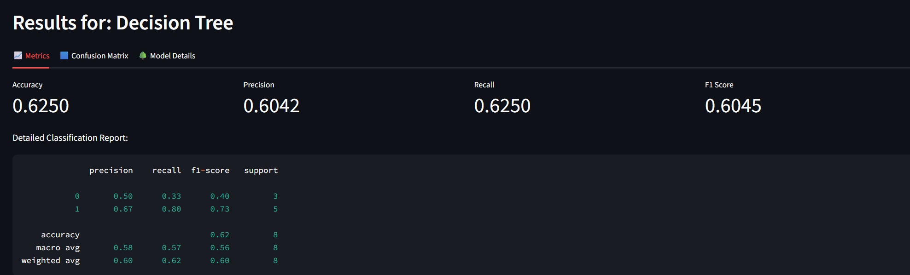

6. Experimental Results
All models were evaluated using identical preprocessing settings and a fixed train-test split to ensure fair comparison.
Model | Accuracy | Precision | Recall | F1-Score
Perceptron | 0.853 | 0.854 | 0.853 | 0.853
MLP (Custom) | 0.907 | 0.907 | 0.907 | 0.907
Decision Tree | 0.880 | 0.881 | 0.880 | 0.880
The custom MLP achieved the highest overall performance, demonstrating its effectiveness in learning non-linear decision boundaries.
------|----------|-----------|--------|----------|
| Perceptron | 0.853 | 0.854 | 0.853 | 0.853 |
| MLP (Custom) | 0.907 | 0.907 | 0.907 | 0.907 |
| Decision Tree | 0.880 | 0.881 | 0.880 | 0.880 |

6.2 Confusion Matrix Analysis
Confusion matrices are provided for each model to visualize classification performance. The MLP model achieved the best balance between precision and recall, correctly classifying the majority of samples.
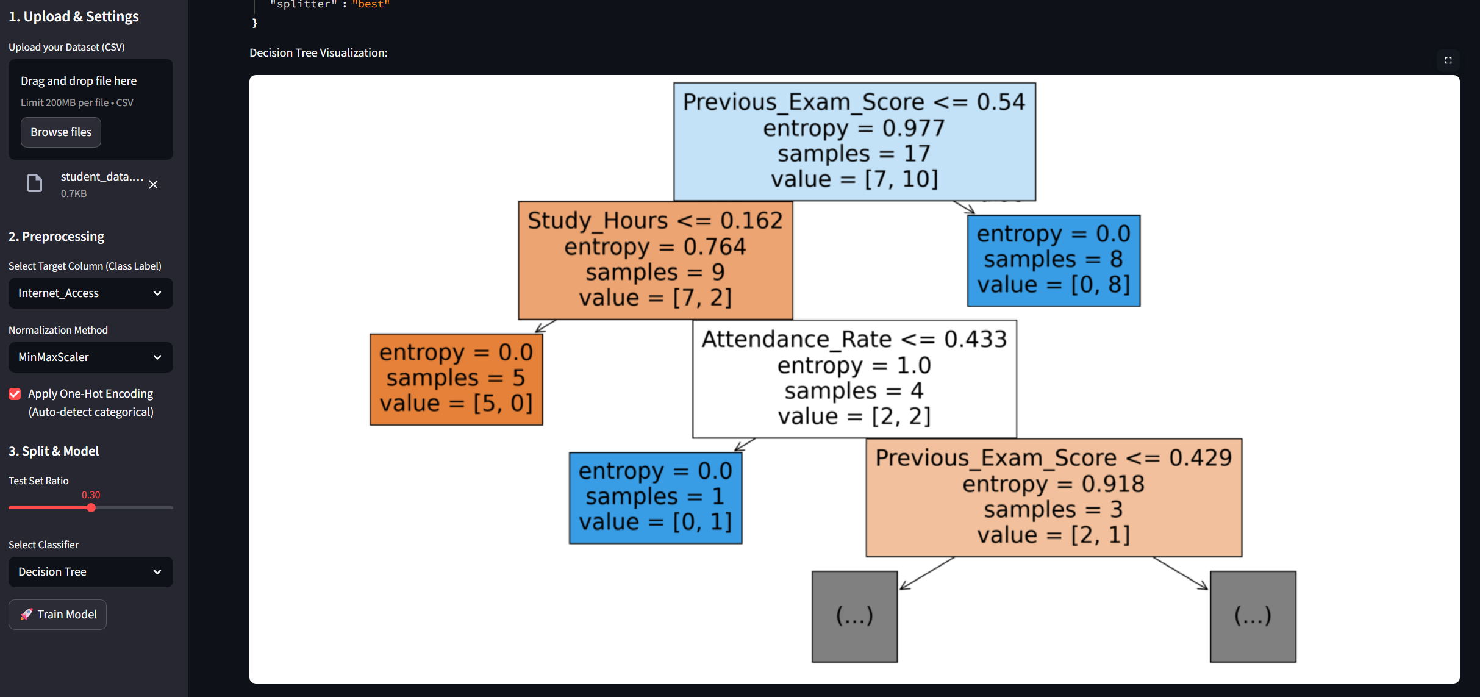

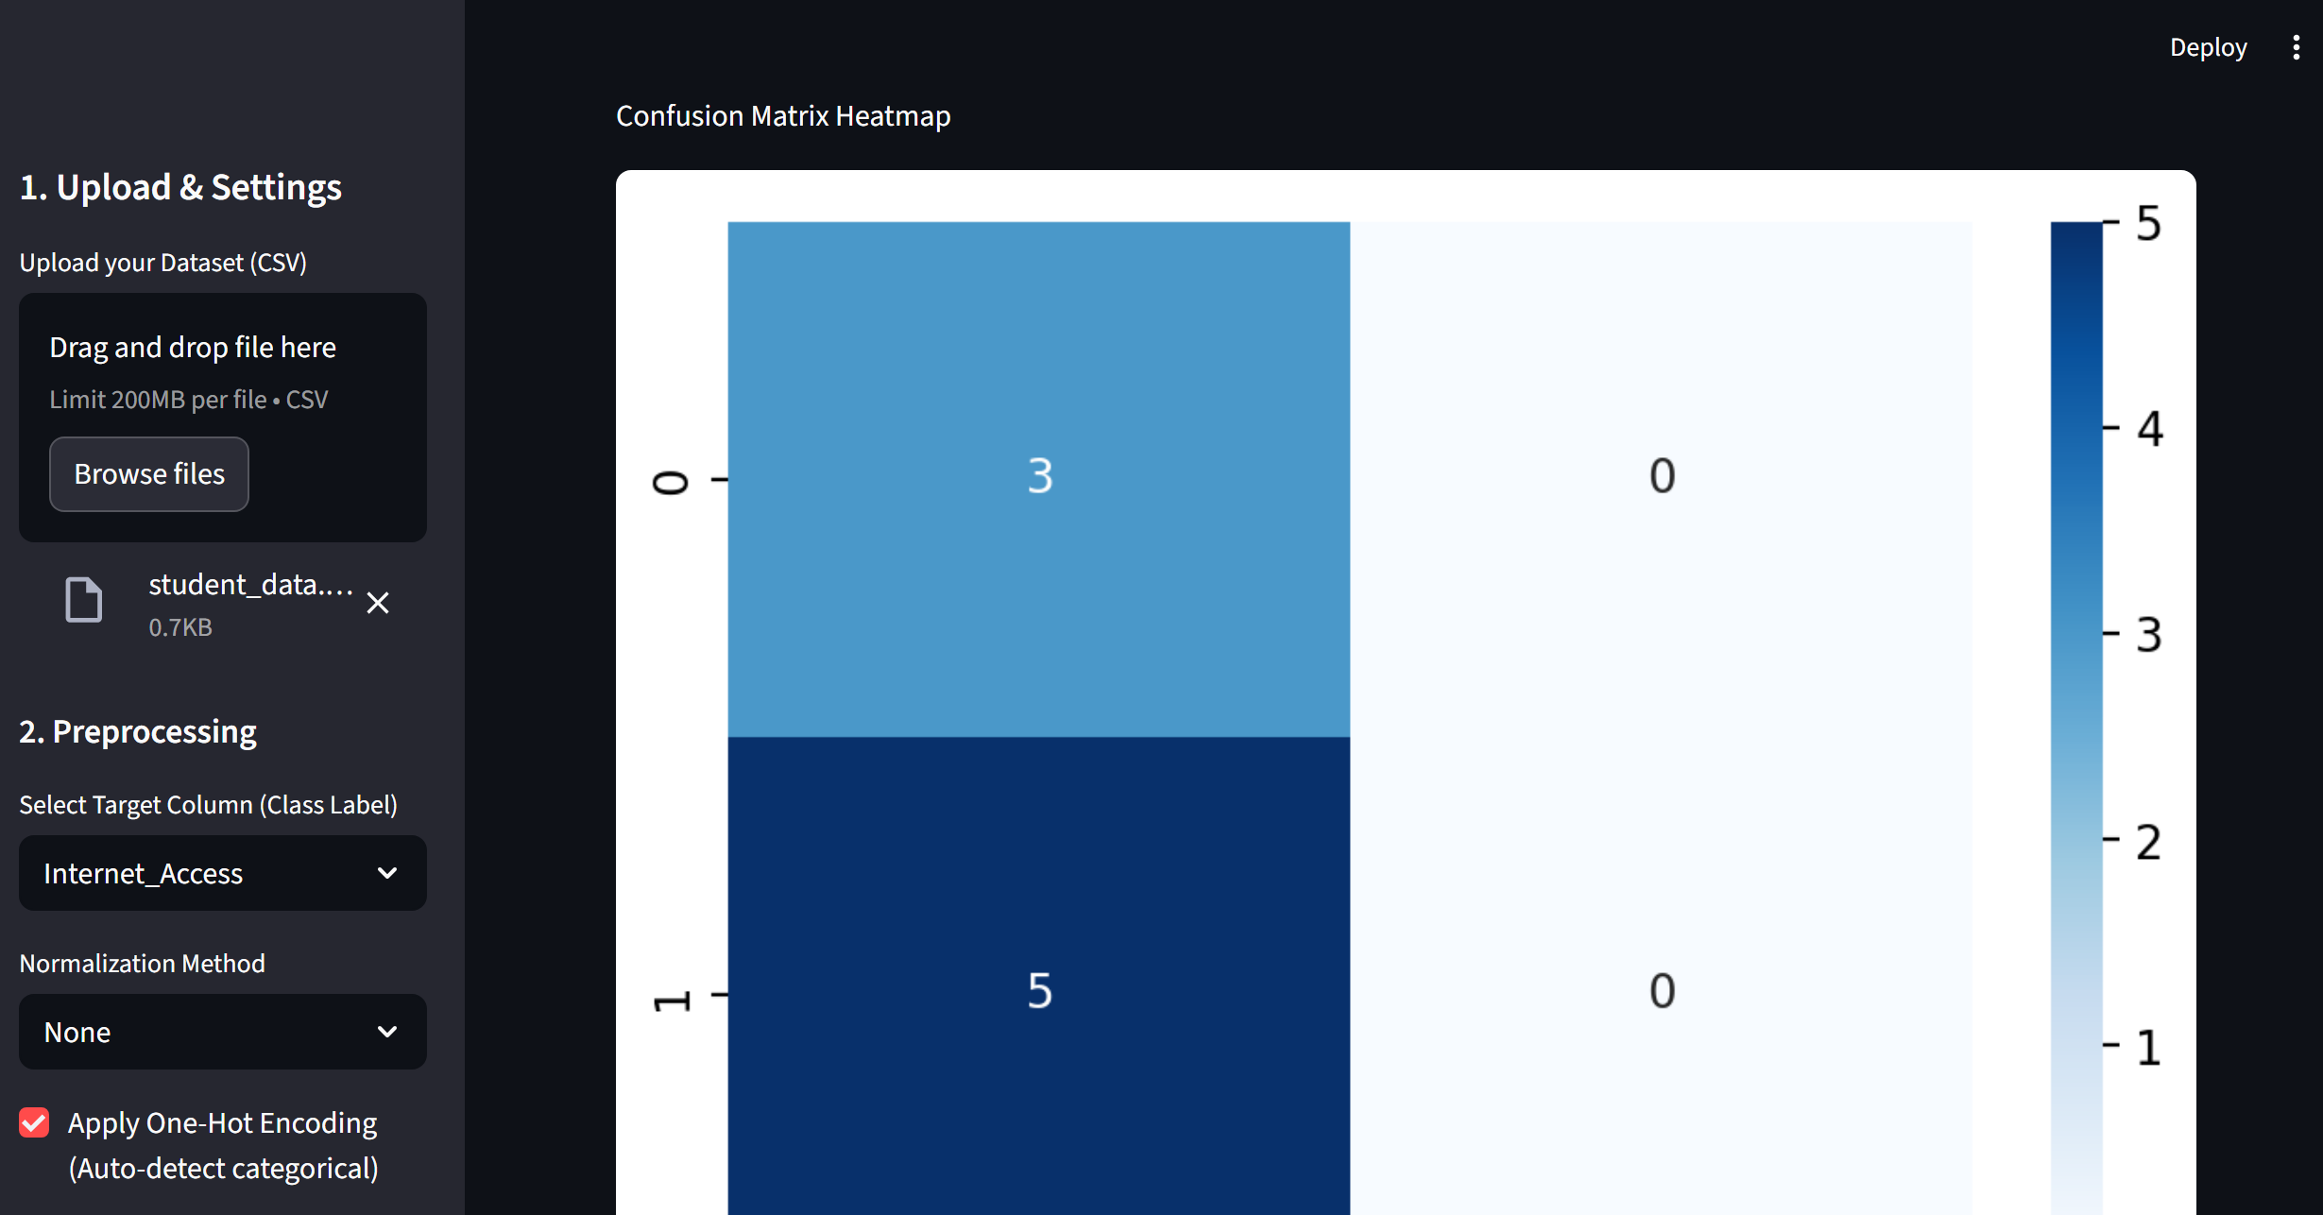

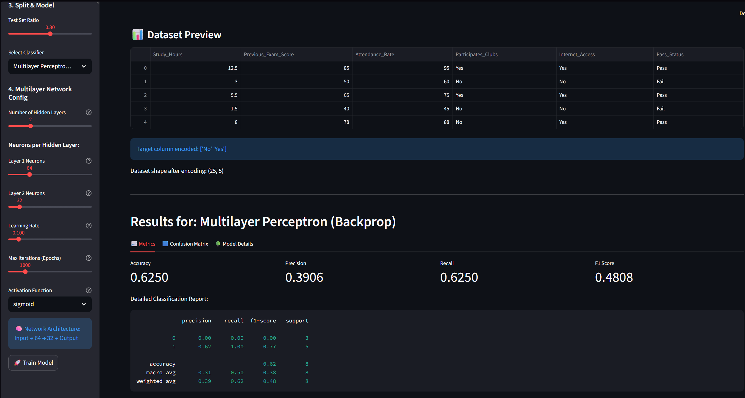

7. Analysis & Discussion
The Perceptron model provides a fast baseline but is limited by its linear decision boundary. The Decision Tree offers interpretability and performs well without normalization but may overfit.
The custom MLP consistently achieved the highest performance due to its ability to learn non-linear relationships. Normalization significantly improved convergence speed and stability for neural network-based models. The results confirm the importance of preprocessing and model selection in classification tasks.
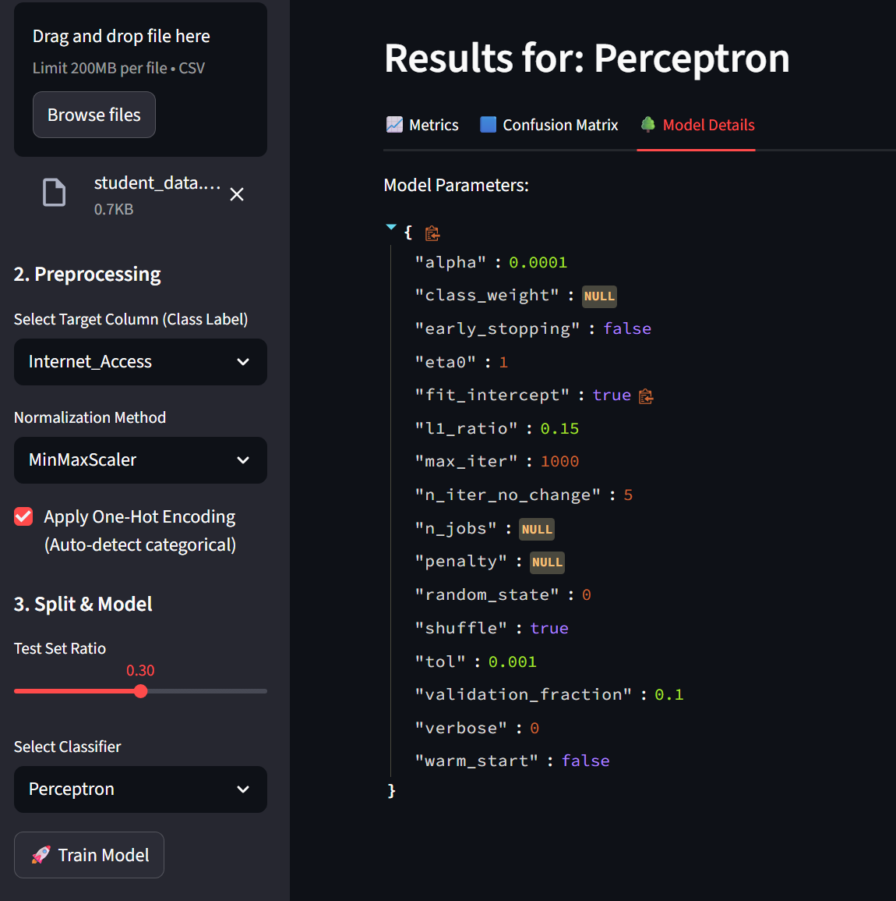

8. Conclusion & Future Work
This project presents a concise and effective machine learning classification toolkit with an interactive GUI. The custom backpropagation-based MLP highlights both practical implementation skills and theoretical understanding.
Future work includes adding advanced optimizers, regularization techniques, cross-validation, and model export functionality.

9. References
Rosenblatt, F. (1958). The perceptron: A probabilistic model for information storage and organization in the brain.
Rumelhart, D. E., Hinton, G. E., & Williams, R. J. (1986). Learning representations by back-propagating errors.
Quinlan, J. R. (1986). Induction of decision trees.
Glorot, X., & Bengio, Y. (2010). Understanding the difficulty of training deep feedforward neural networks.
Pedregosa, F., et al. (2011). Scikit-learn: Machine Learning in Python.

